**YEAR 11 HUMAN BIOLOGY ATAR**

**TEST 5: PREGNANCY, CONTRACEPTION & STIs**

**ANSWERS**

**SECTION 1: MULTIPLE CHOICE: (25 MARKS):**

1. Human cord blood is an important source of stem cells. The cells obtained from cord blood are
   1. Pluripotent
   2. Totipotent
   3. Omnipotent
   4. Multipotent
2. The embryo is surrounded by the amniotic cavity, filled with amniotic fluid. This fluid
3. acts as a shock absorber.
4. provides a medium through which the exchange of materials takes place between the mother and embryo.
5. helps to regulate a constant temperature.
6. produces hormones for the developing embryo.
   1. i and iv only
   2. ii and iii only
   3. i and ii only
   4. i and iii only
7. A woman who has heavy scarring to her uterus and has had several miscarriages in the last few years, wants to have a baby. Which reproductive technology would be best suited to her?
   1. artificial insemination
   2. donor embryo
   3. in vitro fertilisation
   4. surrogacy

**Question 4 refers to the diagram of the heart shown below.**

1. 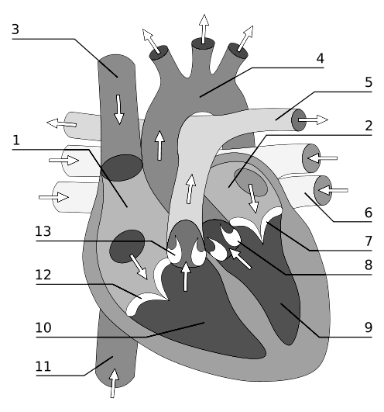A developing foetus has a hole in the heart to allow blood to mix. It is known as the foramen ovale and should close over after birth. When present the foramen ovale connects
   1. 9 and 10.
   2. 4 and 5.
   3. 1 and 2.
   4. 2 and 9.
2. At which physical stage is the developing child especially susceptible to drugs such as thalidomide?
   1. As the primitive heart is starting to beat.
   2. As the limb buds are developing.
   3. As the ossification centres develop.
   4. Just prior to birth.
3. Which type of stem cell has the most potential to differentiate into the greatest diversity of cell types:
4. pluripotent
5. omnipotent
6. multipotent
7. totipotent
8. Women undergo many changes during pregnancy. Which of the following is NOT one of those changes?
   1. Enlarged breasts.
   2. Increase in blood volume.
   3. Increased frequency in the passing of urine.
   4. Increase in digestive system activity.
9. Which of the following contraceptive methods does not prevent the formation of a zygote?
   1. Intrauterine device
   2. Contraceptive pill
   3. Condom
   4. Cervical cap
10. A doctor would be unlikely to prescribe antibiotics for treatment of which of the following pairs of sexually transmitted infections?
    1. Herpes and syphilis
    2. Acquired immune deficiency syndrome and herpes
    3. Syphilis and gonorrhoea
    4. Acquired immune deficiency syndrome and gonorrhoea
11. Which of the following STIs is associated with cancer of the cervix?
    1. Syphilis
    2. Chlamydia
    3. Genital warts
    4. Gonorrhoea
12. Most STIs cannot be prevented by vaccination except for
    1. Hepatitis B and Genital warts
    2. Hepatitis B and AIDS
    3. AIDS and gonorrhea
    4. Syphilis and Chlamydia
13. The contraceptive pill contains
    1. Luteinising hormone and oestrogen
    2. Follicle stimulating hormone and oestrogen
    3. Oestrogen and testosterone
    4. Oestrogen and progesterone
14. Condoms
    1. are a natural form of family planning.
    2. prevent the transmission of some sexually transmitted diseases.
    3. only work when a spermicide is also used.
    4. produce chemicals which reduce the movement of sperm after ejaculation.
15. Oestrogen can be used in contraceptive pills because it
    1. inhibits the production of FSH therefore no ovum develops in the ovary.
    2. inhibits the production of LH allowing ovulation but not fertilization to occur.
    3. stimulates the production of FSH reducing the development of the endometrium.
    4. stimulates the production of LH therefore stopping ovulation.
16. Which is not a sexually transmitted infection?
    1. chlamydia
    2. herpes
    3. syphilis
    4. rheumatic fever
17. Vasectomy in the adult human male causes total loss of
    1. erectile function.
    2. fertility.
    3. sexual desire.
    4. testosterone production.
18. Which of the following methods of contraception operates by preventing the implantation of the fertilised ovum?
    1. the condom.
    2. the Pill.
    3. the intra-uterine device (IUD)
    4. flushing with water.
19. Listed below are some different causes of infertility. Which of them will IVF be unable to assist in achieving a successful pregnancy?
20. A blockage in the fallopian tubes.
21. Erectile dysfunction.
22. Dysfunctional uterus.
23. Hostile cervical mucous.
24. Which of the following symptoms displayed by a new born baby can’t be caused by consuming alcohol during pregnancy?
    1. Low birth weight.
    2. Poorly formed limbs.
    3. Higher incidence of respiratory problems.
    4. Learning disabilities.
25. Which of the following is not a change in circulation that occurs in newborn babies shortly after birth?
    1. Closing of the foramen ovale.
    2. Closing of the pulmonary arteriosis.
    3. Closing of the ductus venosus.
    4. Closing of the ductus arteriosus.
26. Artificial hormone pills have been helpful when given to some people who have been unable to have children; however, the dosage of these pills has to be carefully regulated because an over-dose can cause multiple births. This implies that the effect of the hormone is to
    1. stimulate ovulation in the woman.
    2. stimulate sperm production in the man.
    3. ensure that the embryos remain fixed in the uterus.
    4. increase sexual desire.
27. Research with embryonic stem cells presents ethical issues because one needs to consider
28. the advantages and disadvantages of using the embryonic stem cells
29. how society can fully benefit from the use of embryonic stem cells
30. the moral status of the human embryo
31. the potential commercial benefit and sources of funding for embryo research
32. Colostrum is important for the health of a new born baby because it contains
33. nutrients
34. amino acids
35. vitamins
36. antibodies

Question 24 refers to the diagram below which shows the process of implantation.

*(Source:* [*http://thebrain.mcgill.ca/flash/a/a_09/a_09_cr/a_09_cr_dev/a_09_cr_dev.html*](http://thebrain.mcgill.ca/flash/a/a_09/a_09_cr/a_09_cr_dev/a_09_cr_dev.html)*)*

[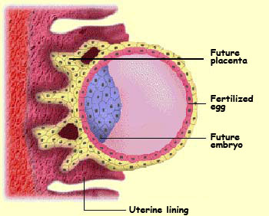](http://www.google.com.au/url?sa=i&rct=j&q=&esrc=s&frm=1&source=images&cd=&cad=rja&uact=8&ved=0CAcQjRw&url=http://thebrain.mcgill.ca/flash/a/a_09/a_09_cr/a_09_cr_dev/a_09_cr_dev.html&ei=GcQXVbHUEomK8QWQooGAAg&bvm=bv.89381419,d.dGc&psig=AFQjCNEB6qmDwOOmOHF4PU6AJlhyoPNxGw&ust=1427707134291812)

1. When the above structure implants into the endometrium, it is known as a:
2. zygote
3. blastocyst
4. amnion
5. morula
6. During stage 2 of labour:
7. the placenta is delivered
8. the cervix begins to widen
9. contractions begin
10. the cervix reaches its maximum dilation

***END OF SECTION 1***

**YEAR 11 HUMAN BIOLOGY ATAR**

**TEST 5: PREGNANCY, CONTRACEPTION & STIs**

**SECTION 1: MULTIPLE CHOICE: 25 MARKS**

**SECTION 2: SHORT ANSWER: 35 MARKS**

**TEST TOTAL: 60 MARKS**

**ANSWER SHEET**

**NAME: ANSWERS**

**SECTION A: MULTIPLE CHOICE: (25 MARKS):**

*Place an* **×** *through the correct response:*

1. [A] [B] [C] [D] 14. [A] [B] [C] [D]

2. [A] [B] [C] [D] 15. [A] [B] [C] [D]

3. [A] [B] [C] [D] 16. [A] [B] [C] [D]

4. [A] [B] [C] [D] 17. [A] [B] [C] [D]

5. [A] [B] [C] [D] 18. [A] [B] [C] [D]

6. [A] [B] [C] [D] 19. [A] [B] [C] [D]

Will accept C

7. [A] [B] [C] [D] 20. [A] [B] [C] [D]

8. [A] [B] [C] [D] 21. [A] [B] [C] [D]

9. [A] [B] [C] [D] 22. [A] [B] [C] [D]

10. [A] [B] [C] [D] 23. [A] [B] [C] [D]

11. [A] [B] [C] [D] 24. [A] [B] [C] [D]

12. [A] [B] [C] [D] 25. [A] [B] [C] [D]

13. [A] [B] [C] [D]

**SECTION 2: SHORT ANSWERS (35 MARKS):**

1. 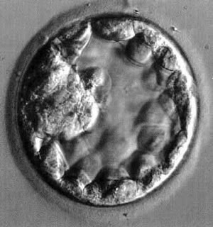Immediately following fertilisation, the zygote begins to divide to form a solid ball of cells. As cell division continues, the cells arrange themselves into a hollow ball of cells as seen in the micrograph image shown below.  
     
   1. What is the name given to this hollow ball of cells? (1 mark)

blastocyst

Small projections from this hollow ball of cells develop and penetrate into the endometrium forming the foetal component of the placenta, the site of exchange of substances between the mother and developing baby.

* 1. What name is given to these projections? (1 mark)

Chorionic villi

* 1. Briefly describe four (4) functions of the placenta. (4 marks)

Any 4 of the following explained for 1 mark each

Endocrine – secretes hormones necessary to maintain pregnancy

Excretory – transports wastes from blood of foetus to maternal blood

Immune – transports antibodies from maternal blood to foetal blood

Nutritional – transports nutrients from maternal blood to foetal blood

Respiratory – transports oxygen from maternal blood to foetal blood and carbon dioxide from foetal blood to maternal blood.

* 1. State the three germ layers formed in the embryo after implantation and for each germ layer, identifyone structure in the adult body that develops from it. (3 marks)

|  |  |
| --- | --- |
| **Germ Layer** | **Structure that forms from it** |
| **Endoderm** | **Epithelium of: alimentary canal and its glands; urinary bladder, urethra, gall bladder, lungs or other arts of respiratory system, tonsils, thyroid etc,vagina & associated glands** |
| **Mesoderm** | **Muscles – skeletal, cardiac, smooth; cartilage, bone & other connective tissue, lymphoid tissue, endothelium of blood vessels & lymphatics, epithelium of: kidneys & ureters; ovaries, testes & reproductive tracts, adrenal cortex,**  **Dermis of skin** |
| **Ectoderm** | **Epidermis of skin; hair, nails & glands of skin; lens, cornea & muscles of the eye; receptor cells of sense organs; epithelium of mouth, nostrils** |

(1/2) mark for each layer and (1/2) for an example of each

* 1. Placental abruption is a condition where the placenta begins to come away from the wall of the womb. Describe one effect this may have on the growing foetus. (2 marks)

Exchange between maternal blood and foetal blood won’t occur [1/2]

So development will be impaired or death will occur as insufficient nutrients and oxygen will reach the foetus and waste products won’t be removed and so will build up in body of foetus [1/2] for one good point.

1. **Describe** **two** **(2)** medical techniques that doctors can use to diagnose foetal health inside the mother’s uterus.

(4 marks)

Any two of the following explained. - [2] marks each for two good points.

Ultrasound

Chromosome analysis

Fetoscopy

Foetal blood sampling

Foetal monitoring

Biochemical analysis

DNA probes

1. Before birth, the *ductus venosus* and the *ductus arteriosus* play an important role in the circulation of the foetus.  
   1. What is the role of the *ductus venosus*? (2 marks)

Liver bypass [1]

Blood returning to foetus from placenta via umbilical veins flows through this (some goes to liver) as liver is not functioning. [1] (or similar)

* 1. What is the role of the *ductus arteriosus*? (2 marks)

Lung bypass (as the lungs are collapsed and offer resistance to blood flow) [1]

Carries blood directly to aorta from pulmonary artery [1]

* 1. What happens to the *ductus venosus* and the *ductus arteriosus* after birth? (2 marks)

Blood no longer flows through both of them as the lungs are inflated and blood no longer flows in the umbilical blood vessels [1]

they constrict, blood no longer flows through them and they eventually become fibrous tissue [1]

* 1. Patent foramen ovale (PFO) is the name given to the incomplete closure of the hole between the atria in the heart of newborns. Discuss the importance of the foramen ovale in foetuses and the possible implications of PFO. (2 marks)

In the foetus it allows direct flow from the right atrium to the aorta to enable the oxygenated blood to reach the foetal tissues very quickly [1]

If PFO occurs then insufficient blood flows to the lungs to get oxygenated and the baby doesn’t get enough oxygen to its tissues – “blue baby” [1]

* 1. Name one Sexually Transmitted Infection that is caused by a virus. (not HIV) (1 mark)

Genital Herpes or genital warts [1]

* 1. What are the symptoms of this infection in males and females? (2 marks)

Genital HERPES: Male – blisters on penis, females – blisters in vagina and vulva.[1]

Possible flu-like symptoms [1]

Blisters can recur for the rest of life.[1] any 2 good points

GENITAL WARTS: warts appear on penis of males and labia, vulva and vagina of females or on other parts of body where sexual contact has been made [2]

* 1. Why aren’t antibiotics effective in curing this infection? (1 mark)

Antibiotics are only effective against bacterial infections

1. For each of the following methods of contraception, give an **example of each and describe how it used and its advantages and disadvantages**: (8 marks)  
   1. Mechanical Barrier

1 mark for example, 1 mark for how used and 1 each for advantages and disadvantages. [4]

* 1. Hormonal:

1 mark for example, 1 mark for how used and 1 each for advantages and disadvantages. [4]

***END OF TEST***